The Battle Of Neighborhoods to Serve Better Facilities to People.

* Introduction to the business problem and who would be interested in this project?
* Data will be used to solve the problem and the source of the data.
* Methodology the section represents the main component of the report that describes the exploratory data analysis.
* Results section to the results.
* Discussion section
* Conclusion section to conclude the report

[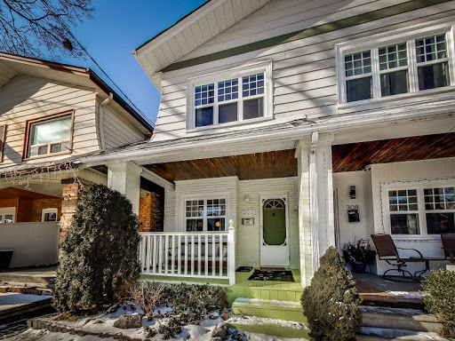](https://www.blogger.com/blog/post/edit/7487870918969629972/7383111080110326466)

**1..INTRODUCTION TO PROJECT**

 Here, In this Project, we will help people to explore new neighborhoods and get better facilities before moving to a new city, state, country, or place for their work. It will help people making a smart and efficient decision on selecting great neighborhoods out of numbers of other neighborhoods in Scarborough, Toronto. Lots of people are migrating to various states of Canada and needed lots of research for good housing prices and reputed schools for their children. This project is for those people who are looking for better neighborhoods. For ease of accessing to Cafe, School, Supermarket, schools, medical shops, grocery shops, mall, theatre, hospital, like-minded people, etc. The aim is to create an analysis of features for people migrating to Scarborough to search the best neighborhood as a comparative analysis between neighborhoods. The features include median housing price and better school according to ratings, crime rates of that particular area, road connectivity, weather conditions, good management for an emergency, water resources both fresh and wastewater and excrement conveyed in sewers and recreational facilities

**PROBLEM TO BE SOLVED:-**

The purpose is to suggest a better neighborhood in a new city for the person who is shifting there. Social presence in society in terms of like-minded people. Connectivity to the airport, bus stand, city center, markets, and other daily needs things nearby. And lot many other things which a person thinks before shifting to any other places

1. **Sorted list of the house in terms of housing prices in an ascending or descending order**
2. **Sorted list of schools in terms of location, fees, rating, and reviews**

[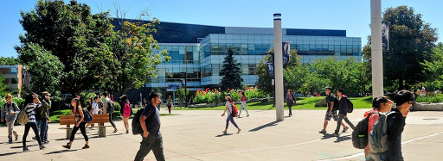](https://www.blogger.com/blog/post/edit/7487870918969629972/7383111080110326466)

## THE LOCATION(Scarborough, Toronto):

Scarborough has welcomed a wave of new immigrants for the past 25 years. Scarborough’s population is made up of immigrants. For many, Scarborough has become a stepping stone for those who want to write a new chapter of their lives in Canada. Roland Coloma is an immigration expert who teaches sociology and equity studies at the University of Toronto. He said a combination of affordable housing, accessible transportation, and proximity to schools, stores, and places of worship has made Scarborough the “ideal gateway community.”

“Historically, immigrants have found Scarborough to be a much more welcoming place for settlement primarily because it has an infrastructure built to support them,” he says.

Affordable housing: "The area has a lot of rental accommodations that are within the price range of low-income Canadians." - Sumit Sen

[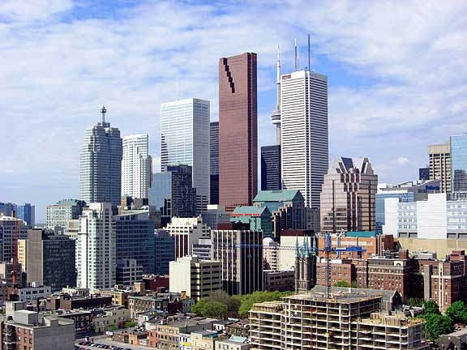](https://www.blogger.com/blog/post/edit/7487870918969629972/7383111080110326466)

**2..DATA REQUIRED :**

**Link of the Data:=** [Data Link: https://en.wikipedia.org/wiki/List_of_postal_codes_of_Canada:_M](https://www.blogger.com/blog/post/edit/7487870918969629972/7383111080110326466)

 The Dataset is Scrapped from Wikipedia website. In this project, we would use Four-square API to collect the data. The Foursquare Places API provides location-based experiences with diverse information about venues, users, photos, and check-ins. The API supports real-time access to places, Snap-to-Place that assigns users to specific locations, and Geo-tag.

**3..METHODOLOGY :**

We have used Clustering **k**-**means clustering** is a method of vector quantization, originally from signal processing, that aims to partition n observations into **k clusters** in which each observation belongs to the **cluster** with the nearest **mean** (**cluster** centers or **cluster** centroid), serving as a prototype of the **cluster**. To compare the similarities of two cities, we decided to explore neighborhoods, segment them, and group them into clusters to find similar neighborhoods in a big city like New York and Toronto. To be able to do that, we need to cluster data which is a form of unsupervised machine learning: k-means clustering algorithm.

[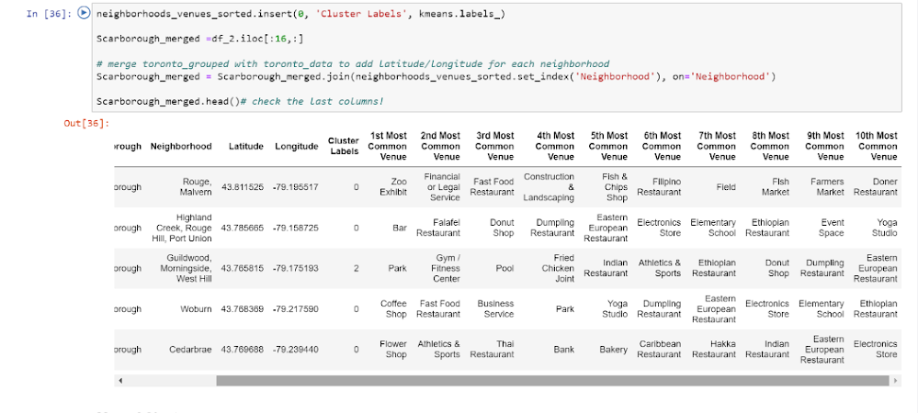](https://www.blogger.com/blog/post/edit/7487870918969629972/7383111080110326466)

**5..RESULTS:**

Now we got the results, Here we have the map of all the Clusters in Scarborough, Average housing price and Schools rating in Scarborough so that the people get a clear picture where they want to live according to their lifestyle and needs.  The people migrating to Scarborough can search the best neighborhood as a comparative analysis between neighborhoods.

**Map of Clusters in Scarborough**

[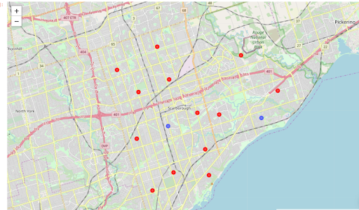](https://www.blogger.com/blog/post/edit/7487870918969629972/7383111080110326466)

## ****Map of Clusters in Scarborough****

**[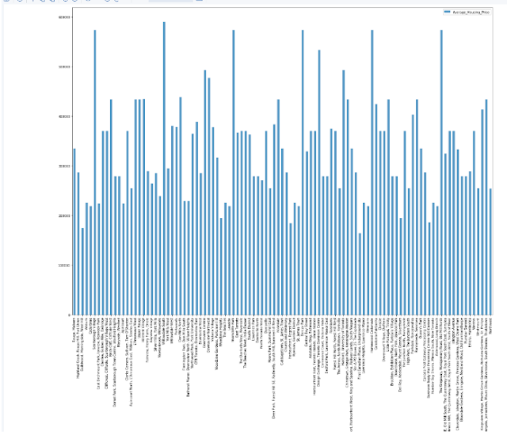](https://www.blogger.com/blog/post/edit/7487870918969629972/7383111080110326466)**

## ****Average Housing Price by Clusters in Scarborough****

[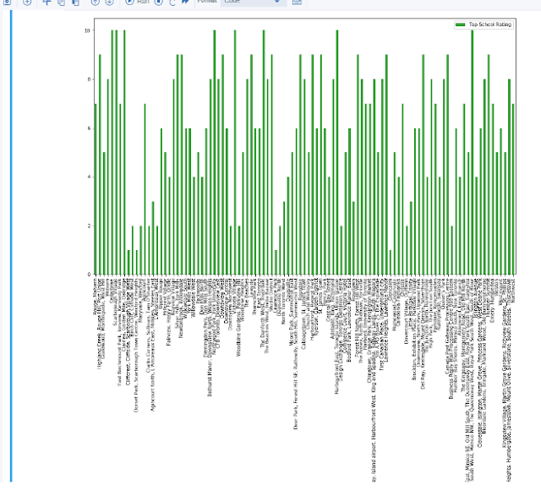](https://www.blogger.com/blog/post/edit/7487870918969629972/7383111080110326466)

## ****School Ratings by Clusters in Scarborough****

**5..DISCUSSION :**

The major purpose of this project is to suggest a better neighborhood in a new city for the person who is shifting there. Social presence in society in terms of like-minded people. Connectivity to the airport, bus stand, city center, markets, and other daily needs things nearby.

**6..CONCLUSION:**

In this project, I have used the k-means cluster algorithm I have separated the neighborhood from the dataset, which has very-similar neighborhoods around them. Using the charts above results presented to a particular neighborhood based on average house prices and school ratings have been made.